Security Principles

SOMILA.SA

231901052

EX-NO: 02 DATE:19:02:2025

AIM: Learn about the security triad and common security models and principles.

PROCEDURE:

Task 1: Introduction

Task 2: CIA

Task 3: DAD

Task 4: Fundamental Concepts of Security Models

Task 5: Defence-in-Depth

Task 6: ISO/IEC 19249

Task 7: Zero Trust versus Trust but Verify

Task 8: Threat versus Risk Task

9: Conclusion

Task 1:

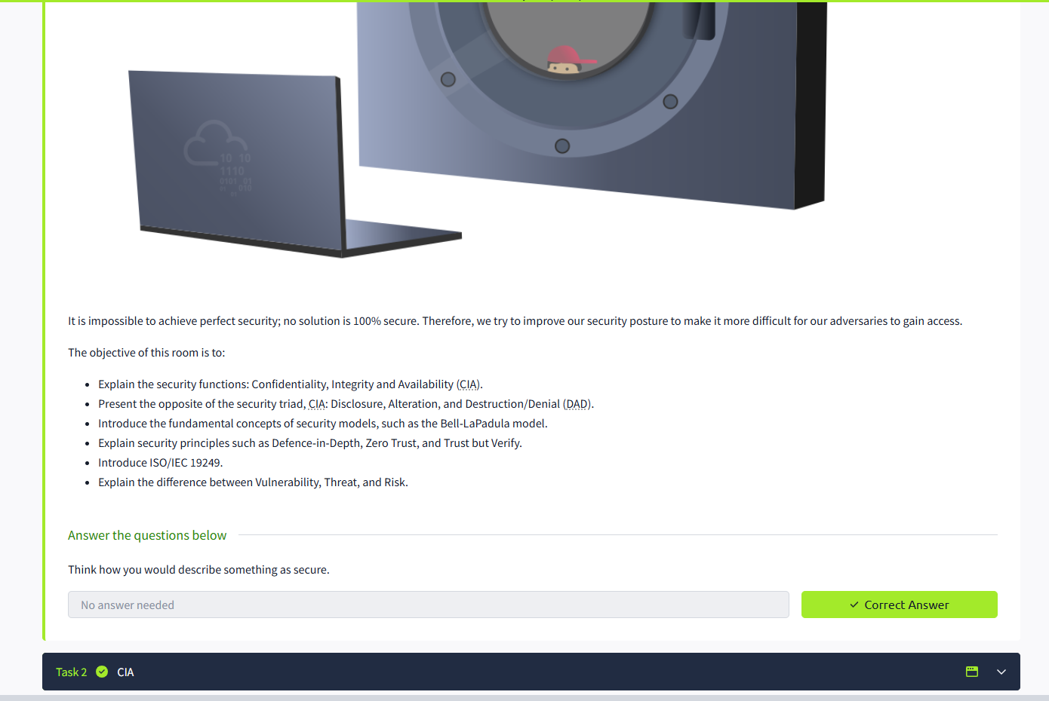

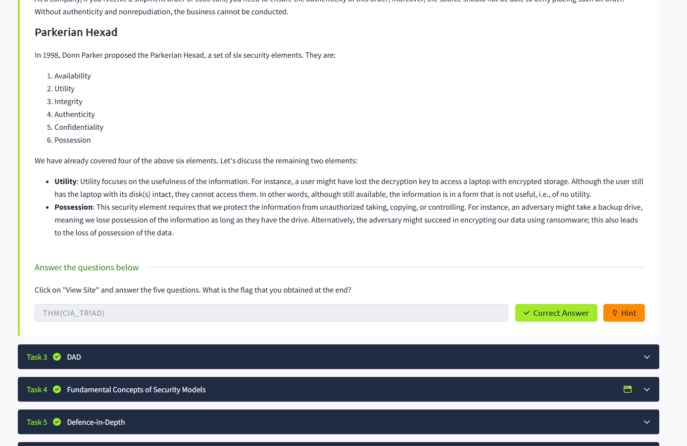

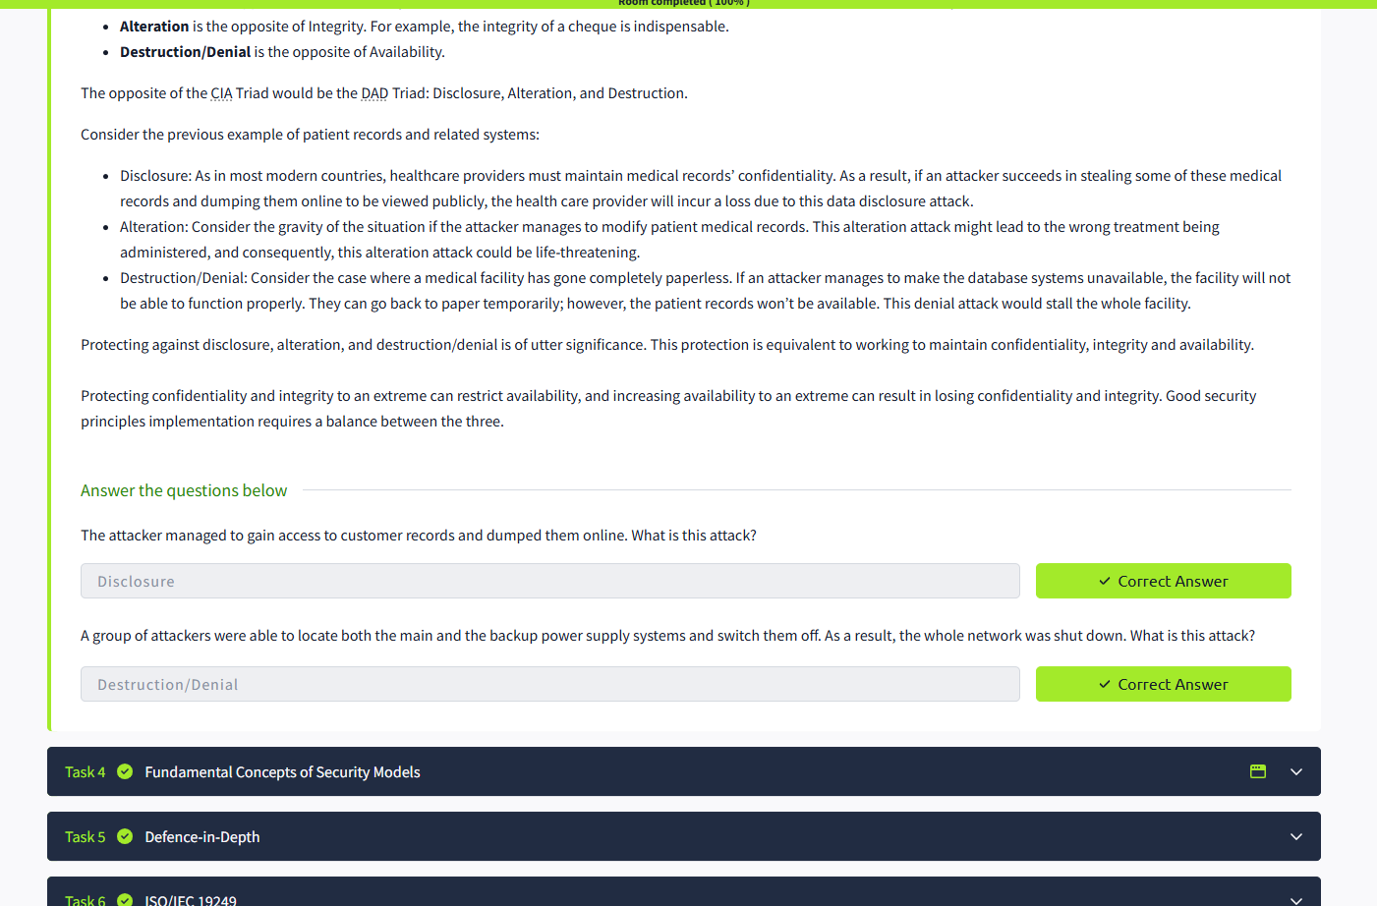

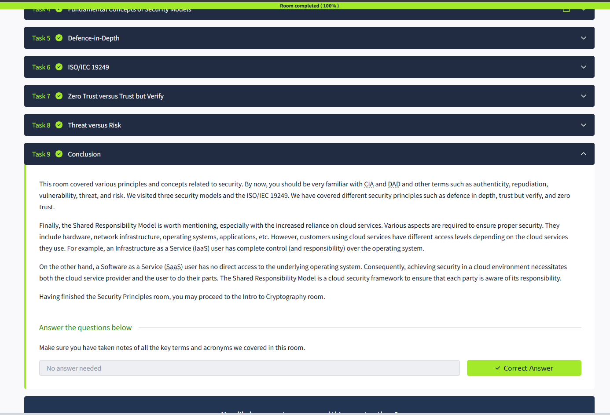

RESULT: Thus the security principles successfully completed in tryhackme platform.